Ornaments as indicators of social changes in northeastern Taiwan before and after the European colonial period

Li-Ying Wang

Ben Marwick

08 July, 2020

Long-lasting indirect impacts on Indigenous peoples in the periphery of colonial control are poorly understood, especially in East Asia. Trade ornaments from Kiwulan (1350-1850 AD) in northeastern Taiwan show the indirect impacts of European colonial activities on local societies. The diversity of ornaments was greater during the period of European presence compared to previous periods, and their spatial distribution was more clustered. This hints at increasing social inequality resulting from colonial influence. Ornaments give insights into the increasing social inequality stimulated by the European colonial presence, and show the agency of Indigenous people to incorporate ornaments into their social system.

# Introduction

The direct impacts of European colonialism on Indigenous communities in East Asia were much less conspicuous than in island Southeast Asia and Oceania. Direct European colonial rule throughout East Asia was rare and limited, and the question of long-lasting indirect impacts on local Indigenous communities remains largely unanswered. Understanding the indirect effects of colonialism are important for detecting colonial impacts on Indigenous peoples in the periphery of colonial control (Acabado 2017; Trabert 2017). In many parts of the world, the introduction of foreign trade goods by colonial traders into local Indigenous societies caused substantial transformations of Indigenous economic, cultural, and socio-political systems (Dietler 2005; Dietler 1997; Junker 1993; Silliman 2005). Consumption patterns of foreign goods can give insights into negotiations between colonized and colonizer, and the resistance and accommodations of Indigenous people through their daily cultural practices (Dietler 2015; Given 2004; Mullins 2011; Scaramelli & Scaramelli 2005; Silliman 2001; Torrence & Clarke 2000; Voss 2005). Northeastern Taiwan is an ideal context to study peripheral colonial influence because although there was a prominent Spanish and Dutch colonial presence in parts of Taiwan, the northeastern region was isolated from intensive direct contact by the Xueshan Mountains.

This article describes personal ornaments excavated from the upper component of Kiwulan (1350 AD-1850 AD), the largest Iron Age settlement on the Yilan plain in northeastern Taiwan. Ornaments are found at many Iron Age sites in Yilan, but only Kiwulan shows clear stratigraphic contexts from pre-European period to modern time. The first recorded European presence in Yilan was a Spanish revenge attack on Indigenous villages in 1632 (Borao 2001: 163). In 1647 the Dutch attacked villages and forced them to accept colonial rule and pay an annual tribute (Andrade 2007). According to Dutch census reports in 1650, Kiwulan was the largest Indigenous settlement in the plain, with a population of 840 adults (Nakamura 1938: 12). Following defeat of Dutch by the Chinese general Koxinga in 1661-1662, the Dutch abandoned northern Taiwan. Direct contact with Han Chinese is indicated by Qing dynasty census reports mentioning Yilan villages in 1821 (Yao 1996).

One of the most commonly traded types of object in this region were ornaments such as glass and stone beads (Chen 2007; Li & Chiu 2014; National Musuem of Taiwan History 2005). Personal adornments in the archaeological record are useful as signal of an individual’s status (Joyce 2005; Scaramelli & Scaramelli 2005). The consumption of stone beads in Southeast Asia during Iron Age is often associated with increasing social stratification or socio-political complexity (Bellina 2014; Carter 2016; Francis 2002; Theunissen *et al.* 2000; Kenoyer 2000). In this paper, we explore archaeological ornaments from Kiwulan spanning the pre-European contact period, period after the Spanish and Dutch presence, and the following period after the Chinese presence. We address the question of whether indirect colonial influences on the Indigenous populations can be detected through the ornament assemblages.

# Ornaments in complex exchange network during the late Iron Age and early historical period

The island of Taiwan lies at the junction of mainland China, Southeast Asia, and Northeast Asia in the Pacific Ocean. The prehistory of Taiwan island could be roughly divided into three major periods, Palaeolithic (c. 27,000 BP- 5000BP), Neolithic (c. 6500- 2000BP), and Iron age (c. 2000- 400BP) with slight regional differences in onset of each period and variations in style of artifacts and assemblages (Chen 2017; Liu 2011). It is generally accepted that Taiwan entered the historical period in the early 17th century due to the colonial activities of the Spanish and the Dutch who played an important role in keeping written records about Taiwan. The European colonial presence in Taiwan ended in 1662 when the Dutch were defeated by the kingdom of Tungning, founded by Koxinga from China. Later in 1683, Taiwan was incorporated into the Qing dynasty in China and a large wave of Han Chinese migrated to Taiwan during the late 18th century. Because of natural safe harbors, northeastern Taiwan was involved in a regional trade network through cross-culture interactions with Chinese merchants since the 14th century, and later the global trade network with the Europeans in the 17th century brought more trade goods circulated in Southeast Asia into Taiwan (Chen 2005; Liu & Wang 2017). Although located on the periphery of regional trade centers, Yilan was connected to trade networks via visits of other Indigenous groups, Chinese merchants, and Europeans, via sea.

The European presence in northern Taiwan started with the Spanish who founded Fort San Salvador at Heping Dao, Keelung in 1626, and Fort San Domingo in 1629 at Tamsui (Figure 1). They sent missionaries to local Indigenous settlements in this region (Blussé & Everts 2000: 343) and kept records about their observations of Indigenous communities. A Dominican priest in 1632 reported that the Taparri, an Indigenous tribe from northern Taiwan, exchanged carnelian beads with other Indigenous groups. This form of exchange was widespread and even the Spanish soldiers used carnelian beads as bargaining chips for gambling (Li & Wu 2006: 132–49). The use of beads as prestige goods is further indicated by their role in bride price payments, and compensation to resolve disputes (Li & Wu 2006: 132–49). Other records mention that the women shamans in the tribe would use carnelian beads as magical items in ritual healing practices (Borao 2009: 122–51). Records of an Indigenous funeral describe the use of carnelian beads in ritual contexts, with more carnelian beads, pottery, and cloth placed into the graves of more influential people to indicate their family’s higher status (Li & Wu 2006: 153). While a full critical analysis of these historical accounts remains to be produced, we take them to minimally indicate that carnelian beads were already treated as prestige goods in Yilan before the arrival of Europeans. In 1642, the Dutch Vereenigde Oostindische Compagnie (VOC) defeated the Spanish and took over their forts in northern Taiwan. They introduced a feudal system in an attempt to control the Indigenous communities by asking Indigenous leaders to attend an annual ceremony for demonstrating their loyalty and paying tribute (Andrade 2007, ch. 9; Kang 2016, ch. 4). The Dutch provided beads and other goods based on negotiations with Indigenous communities to secure alliances in the annual ceremony or during their travels (Kang 2016, ch. 6). We might predict that the activities of the Dutch feudal system to build and maintain alliances resulted in an increase in the amount and diversity of ornaments in northeastern Indigenous communities during this period.

Chinese historical records from 1829, 1837, and 1852 during the Qing dynasty (1616-1911) contain some notes on the purposes of ornaments from Yilan (Chen 1963: 228, 308; Ke 1993: 11, 126; Yao 1996: 77). According to those records, Indigenous people in Yilan wore ornaments in ceremonial contexts to display their wealth and status. Among those ornaments, fish-shaped necklaces made of metal threads had high value due to their delicacy and the exotic materials invested in production. These were usually possessed by wealthy people. Other people wore carnelian beads or glass beads on their head or neck to participate in ceremonies. In 1895, at the beginning of Japanese colonization, an academic field survey for plains Indigenous groups reported that fish-shaped metal necklaces were not used in Yilan at that time, but elderly people still used beads (Ino 1996: 227–32). Although these historical records are fragmentary and may contain some biases (Galloway 2006) that have not yet been studied in detail, we find consistency among multiple sources in their descriptions of how ornaments represent high status or specialized social roles in Indigenous communities in Yilan. Compared to the European period, there are fewer documentary mentions of beads in the Chinese period and the descriptions are limited to clothing, but these generally confirm the role of beads as status markers.

Ornaments found in northeastern Taiwan in the early historical period, including glass beads, stone beads, and metal ornaments, are considered to have been imported from other regions. This is because of a lack of archaeological evidence of beadmaking waste, metalworking, or accessible local raw materials. The chemical composition of glass beads from this region shows a high content of lead and, together with the winding/folding technique, these details suggest a Chinese beadmaking tradition (Cheng 2008; Gan *et al.* 2006; Wang 2018). Although there is a wide variety of metal ornaments such as bells, bracelets, rings, and pendants, the common components of metal ornaments are brass and copper, with a small number made from lead and tin that indicates multiple origins that include Southeast Asia (Chen 2011). There is no direct evidence showing European delivery of beads, however, a large amount of the glass beads containing gold foil (hereafter, gold-foil beads) at Kiwulan might have been introduced by the Spanish through economic activities because similar beads were found at Luzon, northern Philippines, as part of the trading route of the Spanish between 16-19th century (Wang & Liu 2007). Both archaeological evidence and historical records indicate northeastern Taiwan was involved in regional networks with East Asia in the late Iron age. These included Chinese merchants trading metal items, clothes, and beads with local Indigenous people in Taiwan in exchange for local resources. The foreign-made large dark brown glazed stoneware jars frequently found in European shipwrecks were also commonly found from many sites in Taiwan, suggesting direct or indirect interactions. Despite the Chinese origin of some ornaments at Kiwulan, there is compelling evidence that a large amount of ornaments found at 17th century sites resulted from European colonial and economic activities in the region.



Figure 1: Map showing the location of Kiwulan, and other places in northern Taiwan named in the text. Map data from naturalearthdata.com

# Excavations at Kiwulan in northeastern Taiwan

Archaeological ornaments from Kiwulan (Figure 1) come from a rescue archaeology project that was conducted between 2001-2004 in advance of a water diversion project and road bridge construction. The excavations used 2 mm and 1.5 mm mesh screens and covered eight open area sections in total of 262 squares (4 m by 4 m) reaching 3,814 m2 (Chen 2007). The nearly 2 m thick archaeological deposits reveal a large amount of artifacts, burials, middens, post-holes, wooden pillars, and stone structures, all of which indicates it was a long-term settlement. Artifact locations were recorded to the 2 x 2 m sub-square they were recovered in; they lack individual point provenance. Based on the continuity of deposition and the frequency of artifacts, the center of the site is the open area consisting of the A and D sections, which is also the study area where our samples come from (Figure 2). In the AD area, post-holes were found aligned in a north-south direction in intervals with construction marks, which have been interpreted as the remains of stilt house structures. At the north margin of the dwelling place were burials that are mostly oriented in an east-west direction.

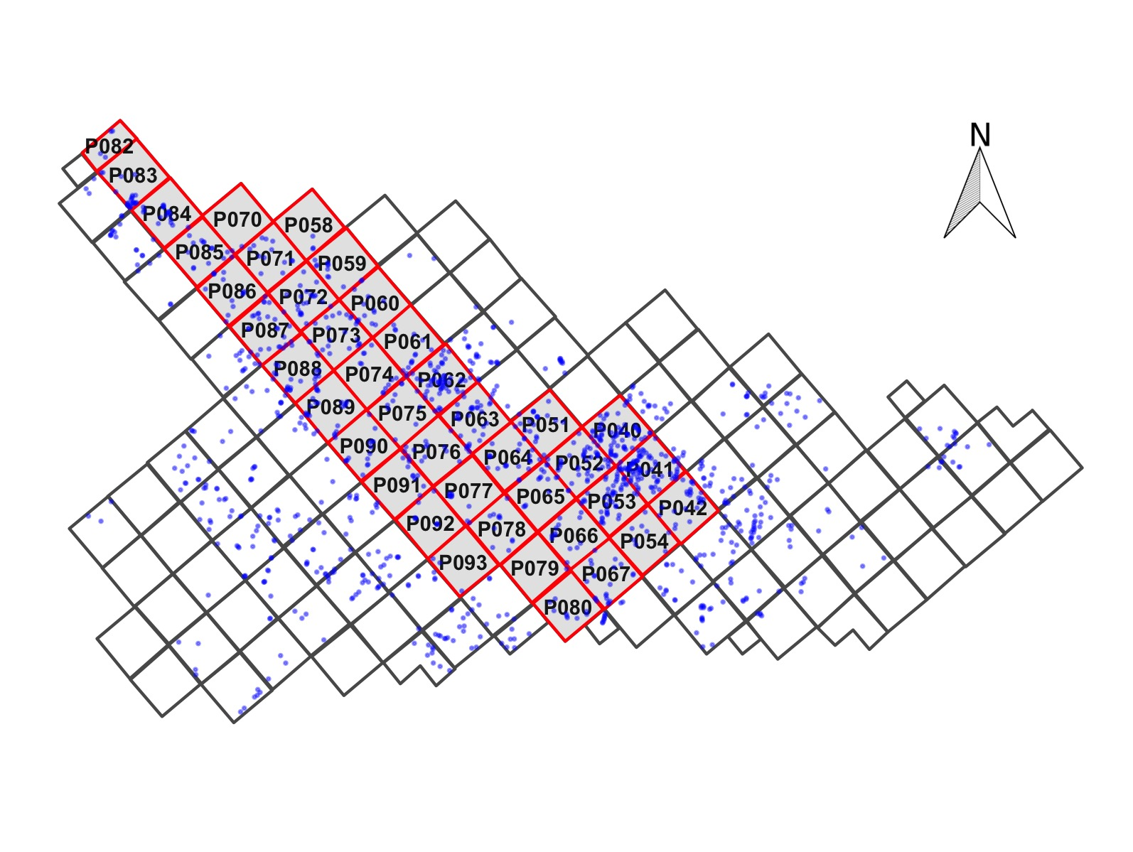

Figure 2: Map showing the largest section of excavation areas at Kiwulan, and the distribution of forty squares sampled in this paper presented in red with square ID numbers. Small dots represent the locations of post-holes. Each square is 4 x 4 m

## Chronology

The chronology of Kiwulan can be divided into two phases represented by a upper component (1350-1850 AD, 600-100 BP) and a lower component (650-1150 AD, 1200-800 BP) based on 32 radiocarbon ages, previously published by Chen (2007), and shown here in Figure 3 and Table 1. There is a sterile deposit between two components spanning c. 150 years that may be related to dry weather, according to pollen analysis, leading to site abandonment (Chen 2007; Lin 2015). These component divisions present the differences in color and texture of the deposit, and the content of artifacts such as pottery types. Whether these two components suggest a culture continuity from the same people is still under debate (Chiu 2004; Chen 2007). We focus on the upper component because this component spans the periods when local residents interacted with the Europeans and the Chinese. In our study area, all excavation squares demonstrate signs of continuous human occupation throughout the upper component. Previous work divided the upper component into six analytical units, spanning from the 14th century to the 19th century, according to the types of chronologically diagnostic ceramics, excavation depth, consistency of contexts, and radiocarbon dates (Hsieh 2009; Wang 2011). To explore the changes in ornament assemblages over time associated with foreign impacts, we assigned the original excavation levels into three phases: before the European contact, after the European presence, and the presence of large Chinese immigrants.

Despite the relatively short period of the European colonization in Taiwan (38-years-long Dutch occupation and 16-years-long Spanish occupation), the indirect impacts of the Europeans through trade network could go beyond the temporal boundaries and last longer. This is because the use of foreign goods in many Indigenous societies often go through the processes of negotiations, resistance, or transformation that a static time frame may not capture the processes well (Scheiber & Finley 2012). Also, we acknowledged that a fine-grained identification of decades of the European presence from the archaeological record is challenging for this study based on three reasons. The current radiocarbon ages that are unable to provide a high resolution of time breaks, the circulation of foreign goods might start earlier before the official European presence in Taiwan, and the use of the foreign goods in Indigenous societies could continue after the end of the European colonization (Mitchell & Scheiber 2010). However, those limitations can be minimized with pericolonial approaches that emphasize the wide-ranging effects of the colonial process, allowing discussion of indirect impacts on Indigenous societies with a more practical and dynamic framework not necessarily defined by a fixed colonial period with a start and an end time (Trabert 2018; Scheiber & Finley 2012).

We acknowledged the approach to study a continuum of changes of archaeological records over time to avoid the pitfall of temporal divides (Scheiber & Finley 2012); however, we also admitted the convenience of using separated time periods for quantitative comparison between temporal groups of imported ornaments. To mitigate the conflict, we separated the ornaments based on the archaeological context that can reflect the acceptance of diagnostic imported goods by their relatively high frequencies as an indicator of indirect colonial impacts. That is, we separated the time periods to before and after a certain foreign presence using the complete archaeological context that contains higher frequencies of time indicators instead of their first appearance in a given layer. This method is reasonable because it allows not only the flexibility of imported goods entering Indigenous societies depending on the agency of local people, but also the application of quantitative analysis to temporal and spatial changes of imported ornaments.

## Method for assigning ornaments

Based on the copies of original excavation records and fieldwork notes, we have made refinements of the original chronology to assign contexts into the pre-European, European, and the Chinese periods with six steps of assigning and evaluations. First, for each unit, we determined the artificial layer (mostly 10 cm) with indirect colonial impacts in terms of the higher frequency of time indicators representing the European and the Chinese period. Second, we identified the archaeological context (normally consists of 2-3 layers) where the layer belongs to based on the description of soil color, soil texture, and density of potsherds and charcoals. We took into account potsherds and charcoals based on the assumption that larger population can be reflected by dense distribution of potsherds and charcoals, and Kiwulan was the biggest settlement with larger population in 1950 (Nakamura 1938: 12). Third, we checked if there are radiocarbon ages associated with the context as a cross validation. Since some radiocarbon ages represent long time ranges, we did not consider the ages that cannot provide useful information. Fourth, we explored any post-depositional issues that might affect the deposition of time indicators to ensure an appropriate assignment based on the fieldwork notes and report. Fifth, we cross evaluated all adjacent squares to confirm a consistent, and continuous context between them. Sixth, we compared our chronology with six analytic units classified by previous studies to make a final decision (Hsieh 2009; Wang 2011). More detailed data information is in Supplementary Online Materials. After assigning the contexts into the pre-European contact, the European presence, and the Chinese presence, we decided the chronology of ornaments by examining in which context they were found. Through those assigning steps with validation rules, we believe our chronology is reasonable and suitable for discussing the indirect colonial impacts led by trade networks.

The archaeological indicators of the indirect impact of the Europeans at Kiwulan are the higher frequency of light grey glazed jars, known as “An-ping” jars in China and Taiwan, and large dark brown glazed stoneware jars that were introduced to Taiwan during the early 17th century. Large dark brown glazed stoneware jars may have been made in Southeast Asia, but are frequently found in European shipwrecks from this period as vessels for transporting water, wine or other liquids on long voyages. The earliest evidence of light gray glazed jars in this region has been found among the cargo of the Spanish shipwreck *San Diego*, which sunk in 1600 AD (Dizon 2016; Hsieh 1995). Southeast China is assumed to be the origin of the light gray glazed jars, however these are commonly found at sites in Taiwan that were associated with European activities, such as the Zeelandia fort site in Tainan (Wang & Liu 2007). The jar shapes found at Kiwulan are typical of those found elsewhere in VOC sites occupied during the 17th century (Berrocal *et al.* 2018: 917; Cort 2017: 282; Grave & McNiven 2013; Ketel 2011; Klose & Schrire 2018: 131). We cannot be sure of the exact process that brought them to Kiwulan: they might have been directly imported by Europeans, by Chinese merchants, or by Indigenous groups via regional networks in north Taiwan. In any case, the high volume of ceramics transported by Europeans, and their high mobility in the shipping trade played an important role in introducing foreign jars to Taiwan.

Those jars were widely distributed across the site and can serve as indicators, together with the radiocarbon dates, to identify the excavation units associated with the pre-European period and the start of European influence at Kiwulan. In addition to stoneware jars as indicators of European presence, around 300 pieces of locally made clay pipes and a few imported pipes were found at Kiwulan. Smoking is likely to have been introduced by Europeans. This custom was widely adopted in many European countries in the 16th century and spread to other regions through interactions (Uçar 2019). We found that the presence of pipe bowls in the archaeological record here is consistent with distributions of glazed jar fragments, which are far more numerous and widespread across the site (n = 1685). It should be noted that these temporal indicators might have been introduced before direct European contact by Chinese traders, and this could result in some uncertainty in identifying the start of European phase. However, the archaeological evidence shows that the layers with abundant trade ceramics match the 17th century according to the excavation report and previous studies (Hsieh 2009; Wang 2011). Thus, we focus on identifying the contexts with high frequencies of those ceramics as indicators the early 17th century.

The archaeological signature of the Chinese period at Kiwulan is the large amount and diversity of Chinese porcelains in many styles and forms such as bowls, plates, and cups. Other indicators include opium pipe-bowls and distinctive architectural bricks and tiles used by Chinese (Hsieh 2009). Chinese migrations to Yilan were also recorded in official Chinese records written in the early 19th century recording the first immigrants in 1768 (Chen 1963; Ke 1993). The details about the distribution of the temporal indicators, accompanied with stratigraphy data, radiocarbon dates, and archaeological contexts for each sampled excavation unit are provided in Supplementary Online Materials.

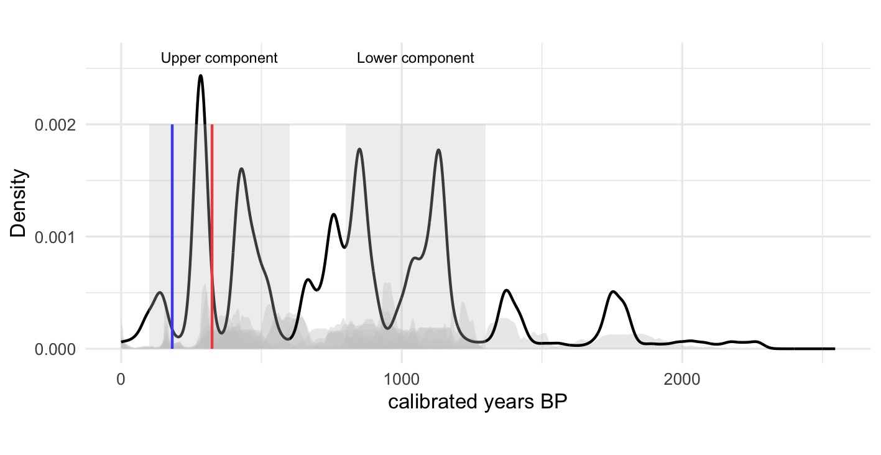

Figure 3: Summed probability distributions for dates from Kiwulan. The dark line represents the summed probabilities of all radiocarbon ages, and the grey lines in the background are the probabilities of individual ages. Grey rectangles indicate the approximate chronology of the major archaeological components of the deposit. For the upper component, the red line indicates the start of European presence, while the blue line is the Chinese presence. Ages calibrated with the Bchron package (Parnell et al. 2008)

Table 1: Radiocarbon ages from charcoal samples excavated from Kiwulan (Chen 2007), calibrated using IntCal13 Atmospheric curve. All depth is recorded in centimeters above mean sea level. The codes in the context column refer to the excavator’s feature labels, cf. Chen 2007

|  |  |  |  |  |  |
| --- | --- | --- | --- | --- | --- |
| Lab code | Pit-Layer | Depth (cm) | Uncalibrated Age BP | Calibrated Age BP (95% credible interval) | Context |
| NTU-3803 | P052-L7 | 0 to -10 | <200 |  | artefact-bearing deposit |
| NTU-3925 | P051-L17 | -36 to -56 | <200 |  | sterile deposit |
| NTU-3943 | P051-L19 | -70 to -90 | <200 |  | sterile deposit |
| NTU-4283 | P063-L12 | -30 to -70 | <200 |  | midden H044 |
| NTU-4293 | P089-L11 | -50 to -70 | <200 |  | artefact-bearing deposit |
| NTU-4305 | P089-L7 | -20 to -30 | <200 |  | artefact-bearing deposit |
| NTU-4322 | P051-L11 | 0 to -40 | <200 |  | midden H026 |
| NTU-4323 | P070-L3 | 20 to -57 | <200 |  | burial M095 |
| NTU-3993 | P041-L7 | -25 to -45 | 250±40 | 4-431 | artefact-bearing deposit |
| NTU-4419 | P162-L3 | -10 to -110 | 280±70 | 12-483 | midden H172 |
| NTU-4311 | P052-L16 | -110 to -130 | 310±100 | 13-512 | artefact-bearing deposit |
| NTU-4320 | P168-L1 | 6 to -51 | 340±100 | 38-528 | midden H193 |
| NTU-4016 | P028-L9 | -44 to -80 | 270±40 | 151-454 | burial M020 |
| NTU-4310 | P018-L2 | -28 to -70 | 360±100 | 71-547 | burial M039 |
| NTU-3791 | P049-L11 | -20 to -30 | 340±30 | 315-483 | artefact-bearing deposit |
| NTU-4292 | P052-L6 | 4 to -56 | 510±75 | 342-648 | burial M009 |
| NTU-4304 | P066-L11 | -40 to -60 | 600±75 | 513-675 | artefact-bearing deposit |
| NTU-4423 | P144-L5 | -10 to -30 | 610±90 | 498-710 | artefact-bearing deposit |
| NTU-4315 | P248-L5 | -100 to -120 | 800±120 | 564-949 | artefact-bearing deposit |
| NTU-3926 | P041-L9 | -70 to -90 | 900±50 | 714-919 | sterile deposit |
| NTU-4421 | P162-L11 | -160 to -180 | 920±70 | 704-952 | artefact-bearing deposit |
| NTU-4319 | P154-L3 | 10 to -10 | 920±105 | 682-1052 | artefact-bearing deposit |
| NTU-4430 | P238-L10 | -130 to -150 | 1020±60 | 796-1059 | sterile deposit |
| NTU-3788 | P028-L15 | -130 to -150 | 1050±40 | 859-1051 | artefact-bearing deposit |
| NTU-4422 | P237-L4 | -70 to -90 | 1030±80 | 765-1151 | artefact-bearing deposit |
| NTU-4428 | P154-L13 | -170 to -180 | 1080±90 | 802-1221 | artefact-bearing deposit |
| NTU-4427 | P246-L8 | -160 to -180 | 1170±70 | 953-1258 | artefact-bearing deposit |
| NTU-4316 | P019-L5 | -100 to -120 | 1190±70 | 967-1263 | burial M066 |
| NTU-3792 | P041-L13 | -150 to -170 | 1240±30 | 1075-1264 | artefact-bearing deposit |
| NTU-4434 | P144-L11 | -130 to -150 | 1480±70 | 1292-1525 | artefact-bearing deposit |
| NTU-4321 | P154-L14 | -180 to -190 | 1870±110 | 1558-2082 | artefact-bearing deposit |

# The personal ornaments

Ornaments (Figure 4) were found in a variety of archaeological contexts including post-holes area, burials, and middens. For the ornament categories, we follow the well-established topology based on raw materials and shapes for the region of northeastern Taiwan (Chen 2007; National Musuem of Taiwan History 2005). This study focuses on 406 ornaments from 40 sampling squares located at the main habitation areas of Kiwulan, indicated by aligned post-holes with *in-situ* posts (Figure 2). Occupation floors were not identified during excavation. We choose these units because they were stratigraphically intact and undisturbed by modern construction activity, compared to excavation squares on the periphery of the site. There are 35 burials in the sampling area, one third of the total number of burials at Kiwulan. Intact ornaments are commonly found in burials used as personal adornment, indicating the property of ornaments as prestige goods. In general, there are some differences between the number of gold-foil beads, carnelian beads, and glass beads across burials. For example, over a thousand beads are found in a few burials, but none is found in some burials. This is also because of the presence of bead strands or patterned bands of beads, which sometimes contain thousands of beads in an individual burial (Chen 2007). The uneven distribution of beads indicate some social differentiation, but a full discussion of the burial data is beyond the scope of this paper.

We focus on ornaments from the habitation contexts (Figure 5, Table 2) because these give us the greatest spatial and temporal representation across the three time periods, and so are most informative of social inequality as indicated by uneven distributions of ornaments. The burials are excluded because most burials from the sampling area date to the European period (n = 21), limiting the usefulness of comparisons between the periods. A possible limitation to our chronological resolution is that ornaments could be heirlooms inherited over multiple generations and well-preserved for a long time. This is difficult to rule out completely, but we consider that because there is no continuous increase in ornament frequency over time, we conclude that accumulation and discard of ornaments is not constant. Thus, we assume that changes in the abundance of ornaments reflect relatively continuous discard behaviors rather than accumulations due to collecting of heirlooms.

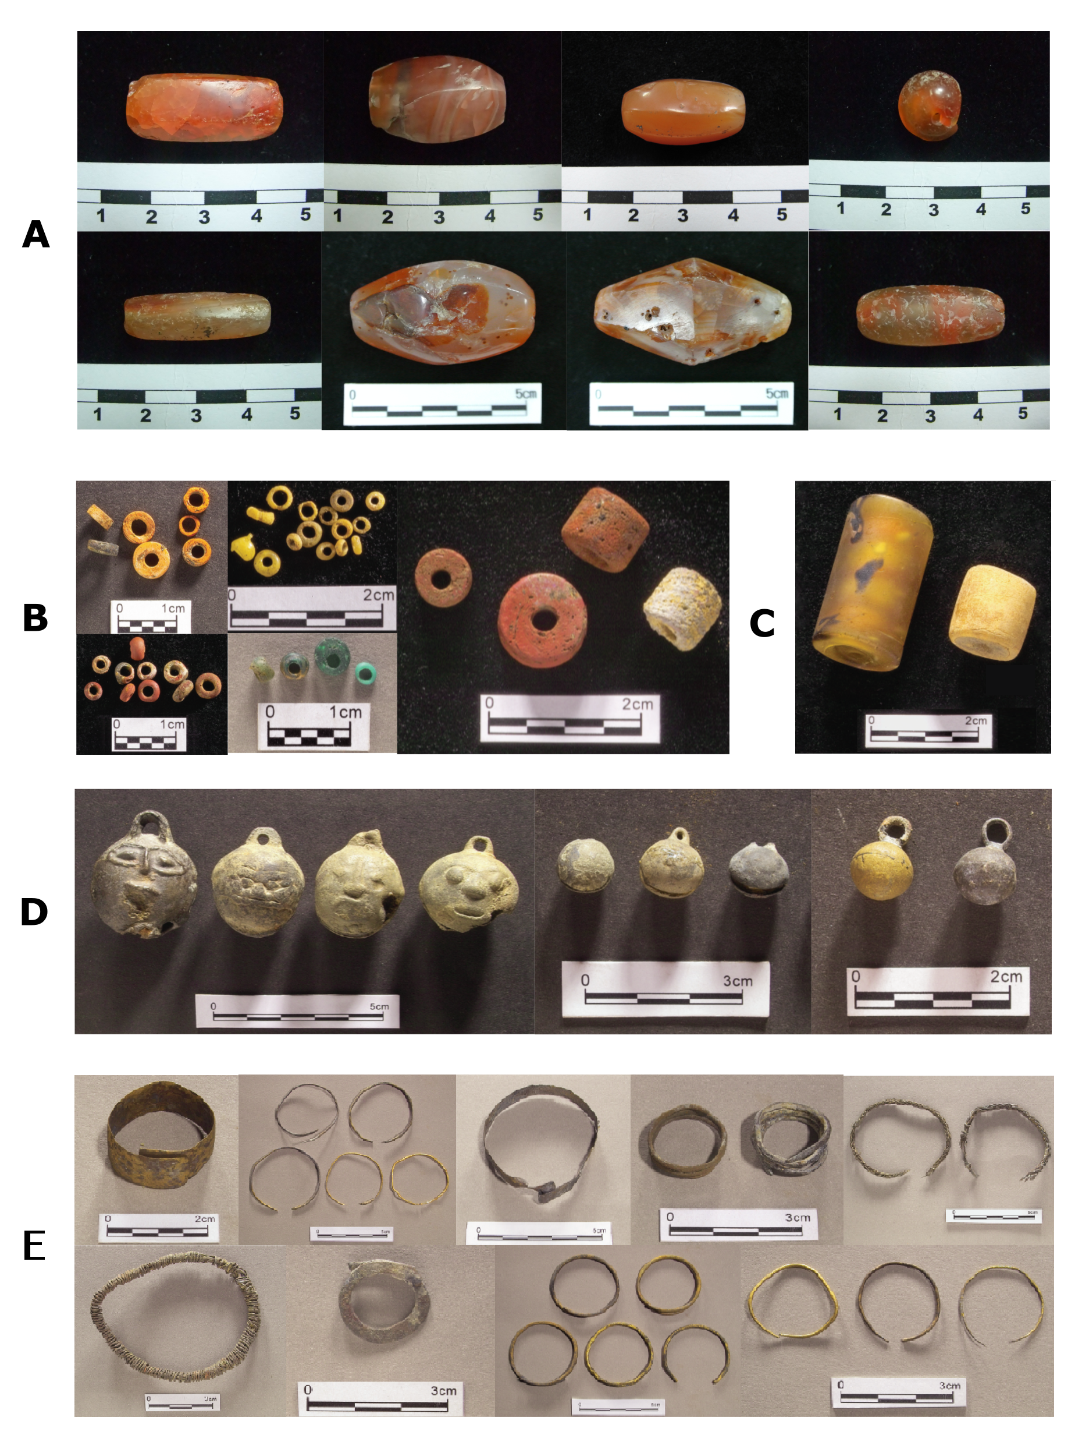

Figure 4: Subtypes of ornament in each major class. A: carnelian beads, B: glass beads, C: gold-foil beads, D: bells, E: metal rings. Photographs are presented in the same order as those subtypes in the table but from left to right instead. The photographs of B, C, D, E classes are from the original excavation report (Chen 2007)

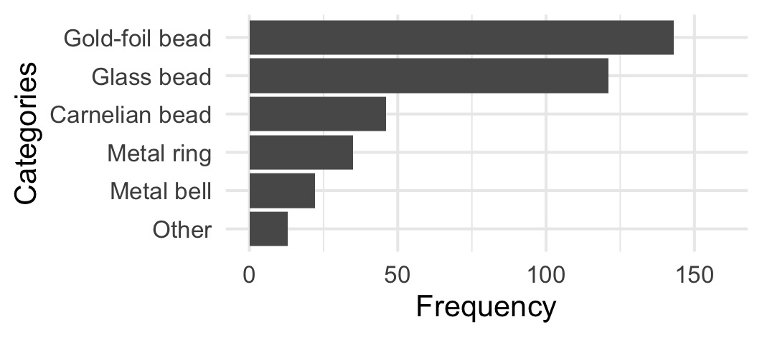

Figure 5: Frequency of the major class of ornaments at Kiwulan. Frequency represents artifact counts totalizaing three periods

Table 2: Frequencies of ornaments by subtype at Kiwulan. Frequency represents artifact counts

|  |  |  |  |  |
| --- | --- | --- | --- | --- |
| Categories | Type | Before European Contact | European Presence | Chinese Presence |
| Carnelian bead | hexagonal | 6 | 17 | 5 |
| Carnelian bead | waxy oval | 0 | 4 | 0 |
| Carnelian bead | small oval | 3 | 3 | 0 |
| Carnelian bead | globular | 0 | 1 | 0 |
| Carnelian bead | pentagonal | 0 | 1 | 0 |
| Carnelian bead | big oval | 0 | 0 | 1 |
| Carnelian bead | long bicone | 0 | 0 | 1 |
| Carnelian bead | octagonal | 0 | 0 | 1 |
| Glass bead | small (0.5-1 cm) | 60 | 37 | 1 |
| Glass bead | medium (1-2 cm) | 8 | 15 | 0 |
| Gold-foil bead | NA | 48 | 93 | 2 |
| Metal bell | large | 3 | 8 | 3 |
| Metal bell | plain small | 0 | 4 | 1 |
| Metal bell | thin small | 0 | 1 | 1 |
| Metal ring | wide small | 1 | 9 | 1 |
| Metal ring | thin large | 4 | 5 | 2 |
| Metal ring | wide large | 0 | 5 | 0 |
| Metal ring | overlapped | 0 | 2 | 0 |
| Metal ring | braid | 0 | 1 | 0 |
| Metal ring | entwined | 1 | 1 | 0 |
| Metal ring | flat | 0 | 1 | 0 |
| Metal ring | large thick string | 0 | 1 | 0 |
| Metal ring | small thin string | 0 | 1 | 0 |

# Reproducibility and open source materials

To enable re-use of materials and improve reproducibility and transparency (Marwick 2017), the entire R code (R Core Team 2019) used for all the analysis and visualizations contained in this paper is included in the Supplementary Online Materials at <http://doi.org/10.17605/OSF.IO/R8YGA>. Also in this version-controlled compendium (Marwick *et al.* 2018) are the raw data for all the visualizations and tests reported here. All of the figures, tables, and statistical test results presented here can be independently reproduced with the code and data in this repository. The code is released under the MIT license, the data as CC-0, and figures as CC-BY, to enable maximum re-use.

# Results

## Changes in the frequencies of ornament types over time

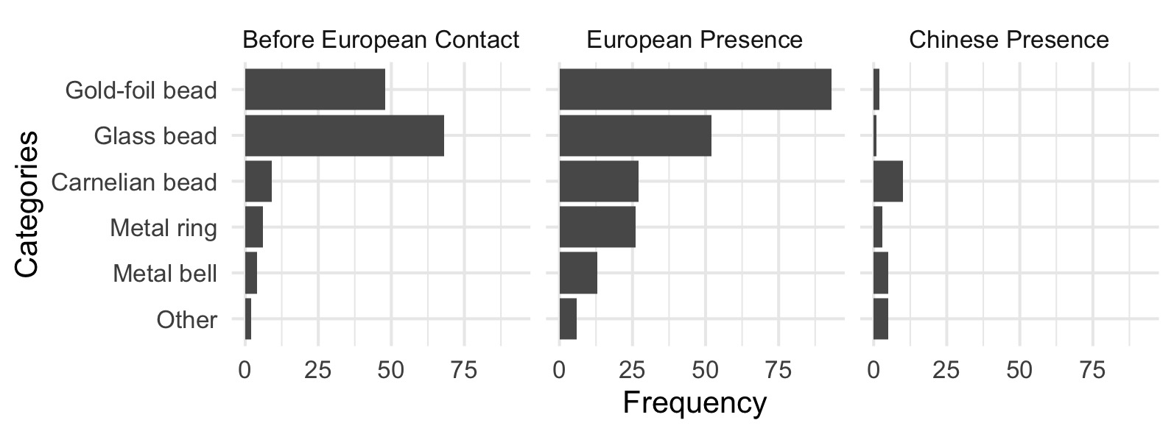

Figure 6: Frequency of the major ornament types across different time periods.

Figure 6 shows the comparison of frequencies of the major classes of ornaments for different time periods at Kiwulan. The difference in frequencies between the three time periods reflect significant differences in the use of ornaments (chi-square = 71.82, df = 8, p-value = $2.14×{10}^{−12}$). Most ornament types were present before European contact. Ornament frequencies reached a peak during the European period and then dropped during the Chinese period, especially gold-foil beads. This trend can be also seen on other ornaments including carnelian beads, metal rings, and bells. However, glass beads show a different pattern that indicates a higher frequency in the pre-European contact, and then a decrease in the European period and a further decrease in the Chinese period. To model the number of ornaments as a function of the mass of ceramics in each period, we used a Poisson GLM with a log link function. The model reveals that ceramic abundance strongly predicts the number of ornaments (β = $1.94×{10}^{−5}$, p = $4.225×{10}^{−29}$). If ceramic abundance is a suitable proxy for population at Kiwulan due to its basic role as cooking vessels, then ornament quantities per period may be influenced by the number of people living at the site.

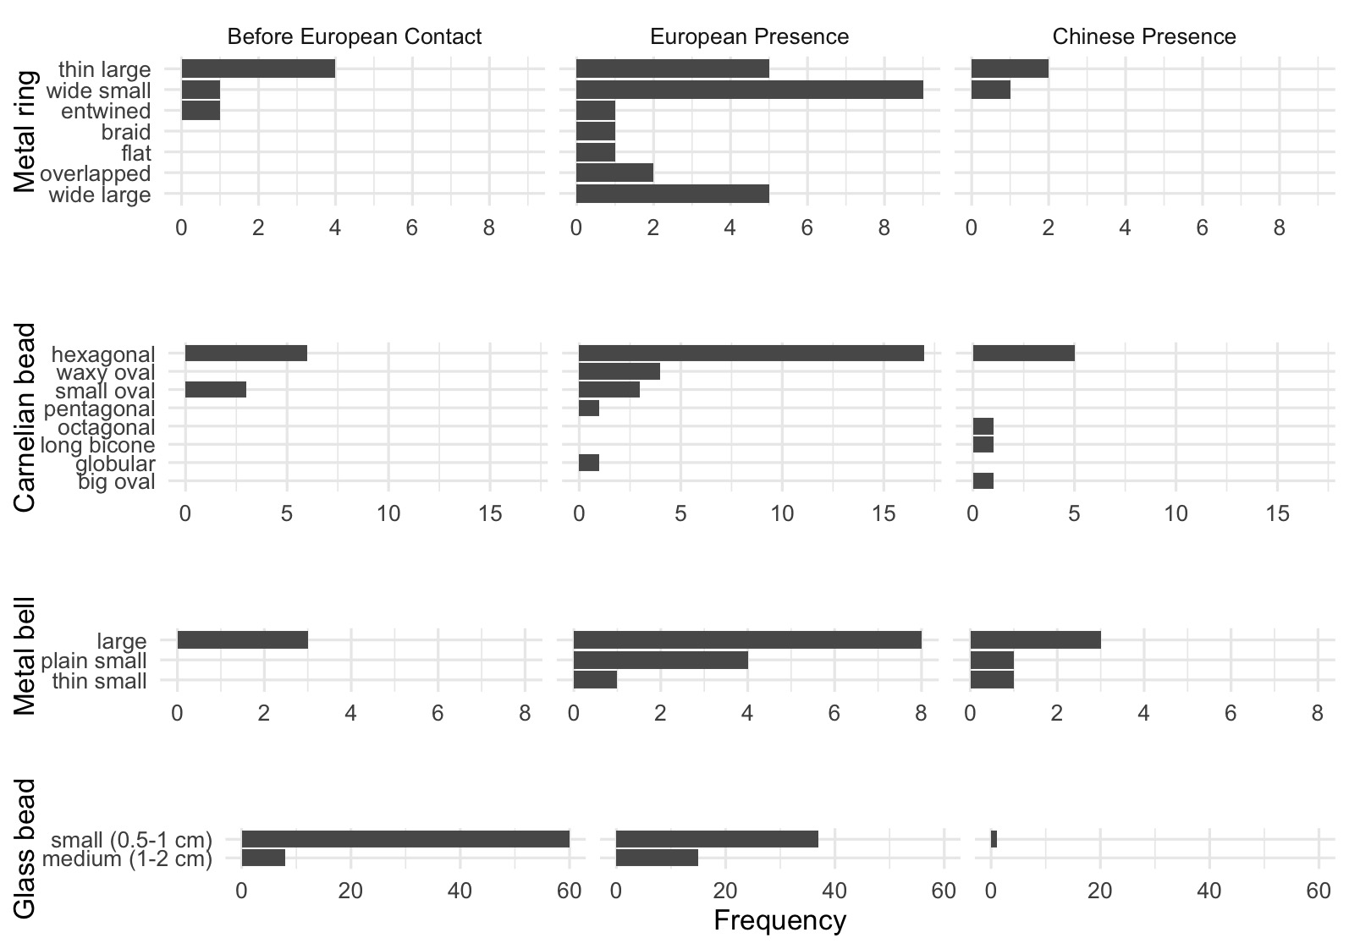

Figure 7: Frequency of ornament subtypes showing the changes in frequency across time periods for metal rings, carnelian beads, bells, and glass beads.

Figure 7 shows the distribution of frequencies for subtypes in each major class. Spearman’s correlation test shows that there is no significant relationship between diversity of subtypes and sample size (S = 1660.07, rho = 0.59, p = $7.3×{10}^{−4}$). This indicates that the increases in diversity can be explained by the effects of culture interaction instead of the effects of sample size. Carnelian beads and metal rings have greater quantity and variety of shapes compared to copper bells and glass beads during the European period. The greater varieties for carnelian beads and metal rings might indicate multiple origins due to participation in large scale trade networks stimulated by the European presence. In contrast, copper bells have less variety, typically >2 cm long with a wide variety of human faces as a motif. Although glass beads have less variety in size, presenting as small (0.5-1 cm) or medium (1-2 cm), they have a wide variety of colors or patterns mostly made by a winding technique and with high lead content indicating possibly from China (Cheng 2008).

Although we are not certain of the specific origin of all kinds of beads, research suggest that glass beads and metal ornaments have similar production techniques and composition to those found in China, while gold-foil beads may relate to the economic activities of the Spanish in the South China Sea region (Chen 2011; Wang 2018). There seem to be no obvious changes in the sources of glass beads or metal ornaments at different phases in the upper component of Kiwulan (1350-1850 AD). However, the glass beads from the lower component (650-1150 AD) demonstrate the composition of m-Na-Al glass and soda plant ash glass that are subtypes of the Indo-Pacific beads, frequently seen in Southeast Asia(Carter 2016; Francis 2002; Wang & Jackson 2014). A transition in the origin of glass beads from mainly Southeast Asia to multiple regions including China might indicate different trading networks. A regional network in South China Sea in the earlier period and later involved in a larger scale trading network stimulated by the Europeans and the Chinese (Hung & Chao 2016; Wang & Liu 2007).

## Changes in patterns of the spatial distribution of ornament types

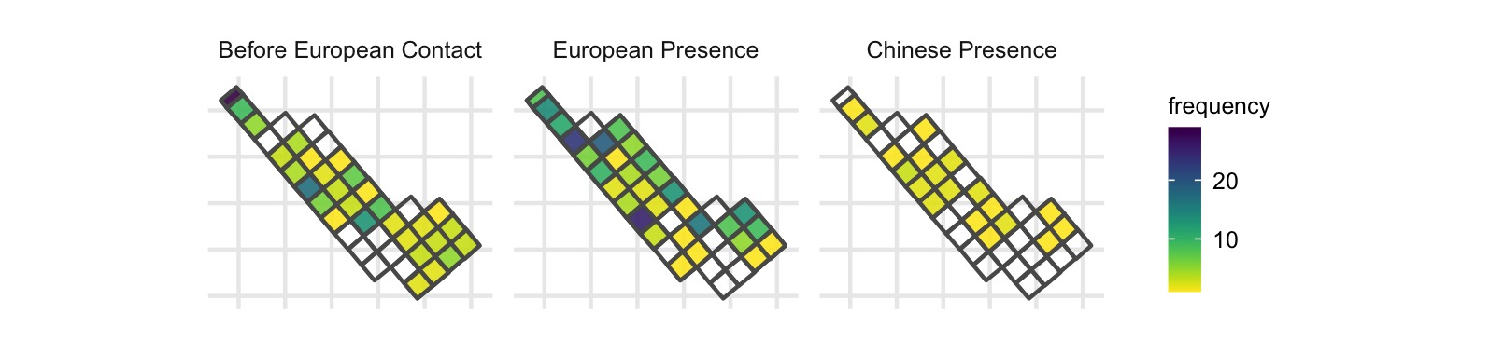

Figure 8: Spatial densities of all class of ornament by time periods.

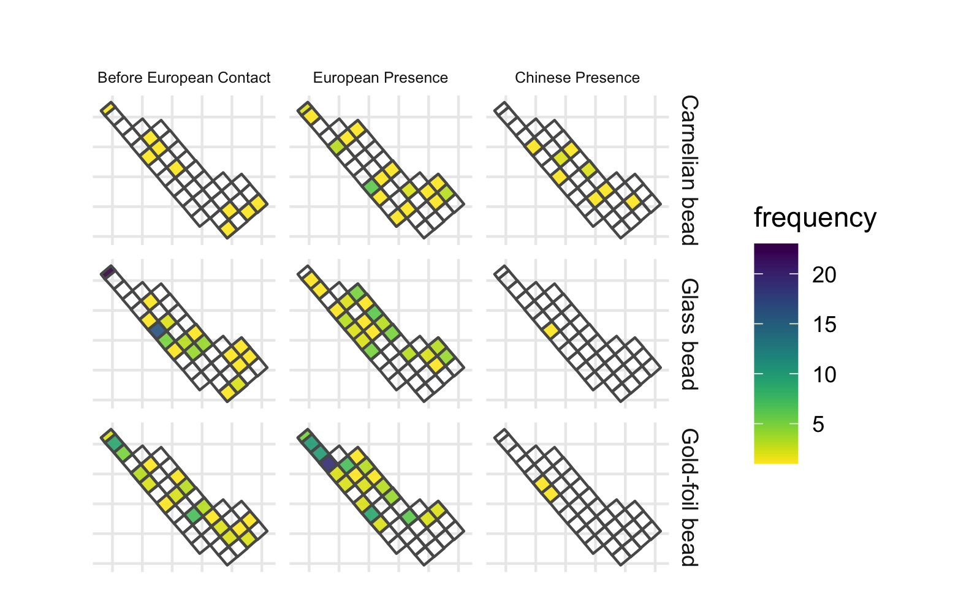

Figure 9: Spatial densities for ornament class by time periods, only those types with more than 5 pieces are shown here.

Figure 8 presents the spatial distribution of all ornaments from the research area for each time period. For deposits predating the European arrival, a greater amount of ornaments were found at the northern and middle parts of the research area. In European period deposits, ornaments were more widespread, with some clusters on the northern part. In units dating to the Chinese period the distribution is more even without clear clusters. Figure 9 presents the distribution for the major ornament classes individually, some clusters across the area can be observed during the European period, such as gold-foil beads and carnelian beads. However, there seems to be no consistent pattern across those different ornaments. Each class shows its own pattern where the squares with higher numbers of ornaments distributed separately and independently. For example, a cluster of gold-foil beads was found at the northern part, while a cluster of carnelian beads was found in the middle part. In contrast, there are multiple clusters of metal rings that are distributed separately across the research area. Copper bells were usually found individually and appear randomly distributed across the area. In the Chinese period, both the amount and density of different classes of ornaments decreased.

## Point pattern analysis of ornament distribution

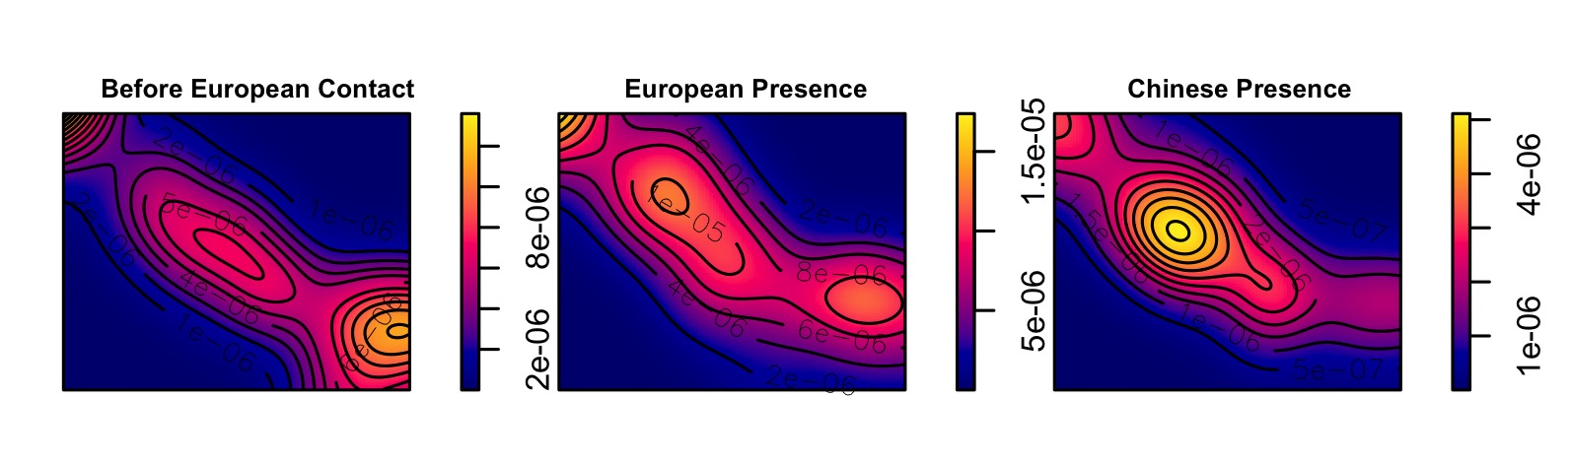

Figure 10: Kernel density map for ornaments by periods, using a bandwidth based on Silverman (1986)’s rule of thumb

The distribution and density of prestige goods across the residential area can provide information on social structure based on the assumption that distribution patterns observed from spatial data can reveal cultural processes (Kintigh & Ammerman 1982). The differential accumulation of artifacts, especially high value goods, in many archaeological contexts can reflect social differentiation or hierarchy in a society (Halstead 1993; Orser 1988; Pearson 1993; Trubitt 2003; Wason 2004). We used point pattern analysis to assess whether the distribution of artifacts represents hotspots produced by non-random processes (Bevan & Lake 2016; Ducke 2015), such as concentrations of ornaments in specific households that might result from social inequality stimulated by a colonial presence. To prepare the ornament location data for point pattern analysis, we assigned each ornament to a random coordinate pair in the square it was recovered from because artifacts from Kiwulan lack exact piece-provenance data. The next step was to divide the ornaments into three time periods. Finally we computed the density maps for each time period for comparison. Density values of artifacts per square meter were calculated for each cell. Here we use kernel density estimation (KDE) for visualization and identification of spatial clusters (Baxter *et al.* 1997), in this case the core areas of ornaments and surrounding neighborhoods. KDE is a method of spatial analysis that computes the probability of the density of ornaments across space by creating a continuous, smooth density surface across space (Bonnier *et al.* 2019; Cortegoso *et al.* 2016).

Figure 10 shows that there is one major core area during the pre-European period, multiple core areas during the European period, and a single core during the Chinese period. There are three consistent sub-regions with a core area that shifts over time. The distribution might indicate an increase and decrease in the number of social groups who possessed ornaments. The multiple groups during the European period might reflect unequal consumption of ornaments across the site, relative to other periods, or random patterns resulting from a bigger sample size. In addition, the generation of core areas might be biased due to small sample sizes, for example, a few ornaments found at one single square during the Chinese period could create an obvious hotspot. Whether the observed clustering is random or non-random is crucial for making reliable interpretations of intentional human activities at Kiwulan.

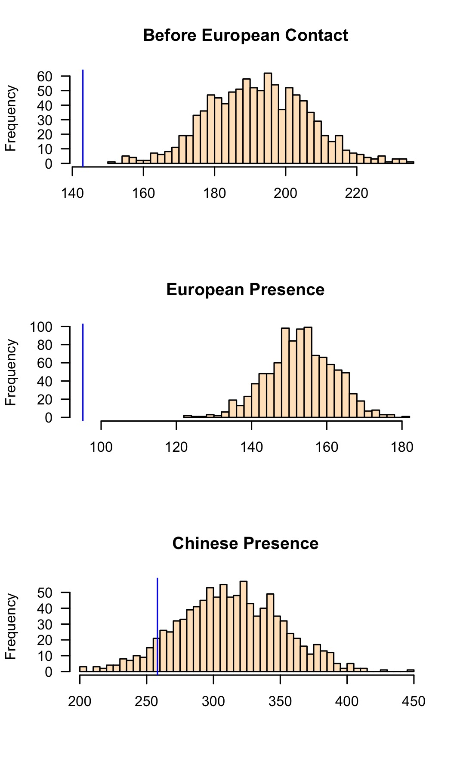

Figure 11: Histograms of simulated ANN values from 1000 simulations for three time periods. X-axis values represent ANN expected values under a completely random process resulting from a simulated pattern. Each sample distribution presents the null hypothesis with the blue line indicating the observed ANN value

To test for randomness in spatial locations, we used a Monte Carlo method to simulate average nearest-neighbour distances (ANN). Figure 11 shows the observed ANN distances with the distributions of the ANN distances calculated on 1000 simulations of random ornament locations. The results show that 100% of the simulated values are much greater than our observed ANN value during the European period, which means the ornaments have non-randomly clustered distributions. A similar, but less extreme, result is also observed during the pre-European period. The observed distribution of ornaments is more similar to the random distributions during the Chinese period, with about one third of the simulated values are greater than our observed ANN value. The Chinese period has fewer artifacts in any category, likely reflecting a smaller population at Kiwulan at this time, making spatial patterns and hotspots difficult to discern with confidence. Our Monte Carlo testing reveals that clustering of ornaments during the European period is highly non-random, potentially indicating different degrees of access to foreign ornaments or a concentration of power to control the distribution of ornaments at Kiwulan during this period.

# Discussion

An indirect colonial influence may be indicated at Kiwulan by the greater diversity of ornament types and materials during the European period. Yilan was involved in complex trading networks both on a regional scale with other Indigenous groups and Chinese merchants, and at a global scale with Europeans, including the Dutch and the Spanish. Those trade ornaments have multiple origins, including Southeast Asia and China, and were first introduced into northeastern Taiwan by Chinese merchants before 17th century. Later, trade activities became more frequent and intense in the 17th century due to European activities. The greater diversity and quantity of ornaments likely resulted from participation in large scale exchange networks that stimulated the circulation of different ornament classes. The frequency of overall ornaments and each subtype declines significantly after European influence fades during the Chinese period in the early 19th century. This may be due to a smaller scale of trading networks, the overall decline of Indigenous populations in Yilan, or the adoption of Han Chinese practices. The decline of the population at Kiwulan may be related to the movement of many Indigenous people southwards to Hualien due to the increasing numbers of Han Chinese immigrants who took over their lands at the end of the 18th century (Chen 2007). Houses and burials may also be a useful source of evidence to understand population size but a proper treatment of those is beyond the scope of the paper.

Archaeological contexts show that ornaments are especially abundant in burial contexts serving as grave goods (Chen 2007). This supports the interpretation of ornaments as valuable objects functioning as status indicators. Spatial patterns of ornaments in dwelling contexts show that their distribution was clustered during the pre-European and European periods. These clusters are non-random, and are most highly concentrated during the European period. This may indicate that a degree of social inequality based on the uneven distribution of ornaments was already present before European contact, and then it was reinforced and amplified during the European period. A further indicator of increased social inequality is a burial dated to the 17th century that included 60 gold-foil beads, well above the average of 2-3 pieces in the pre-European period (Chen 2007; Cheng 2008). Based on the finding of that burial, Cheng (2008) proposed a more hierarchical structure of Kiwulan. However, Hsieh (2012)’s research on burial data suggested a more egalitarian society since a few burials with rich goods are elders that indicates accumulated wealth over time instead of inherited status. Despite the data they used for making inferences are all based on burial contexts, the inferences about Kiwulan social structure are opposite. Our results can provide an additional insight by focusing on the residential area that demonstrated an uneven distribution of ornaments during the European presence, indicating an increasing social inequality. Nevertheless, we still need to explore and compare with other archaeological records to make a better inference to social structure of Kiwulan.

How might these results fit into a bigger picture of social change at periphery of colonial systems? We may get some insight into the general pathways that led to social inequality in northeastern Taiwan by considering how people have achieved and maintained power in a wide variety of societies (Ames 2010; Bowles *et al.* 2010; Drennan *et al.* 2010; Feinman 2000). The corporate/network model proposed expands traditional hierarchical complexity to provide a comparative basis for distinct strategies for power (Feinman 2000). In the network mode, inequality develops when individuals accumulate wealth through their individual networks and people use their wealth to attract factions, control resources, and monopolize trade networks. In contrast, the corporate mode stresses shared power across different groups and sectors, integrative ceremonies and rituals, and large cooperative labour tasks (Feinman 2000; Siegel 1999).

The Kiwulan ornament data may be interpreted as indicating that Yilan social organization moved from a corporate mode, before the European arrival, to a network mode during European presence. The changes from a less concentrated to a more concentrated distribution of ornaments before and after the presence of Europeans appears consistent with the shift from shared power and wealth to accumulated wealth and monopolization. One possible explanation for the shift could be the long-distance trade network introduced by Europeans. The rarity and the image of colonial power of foreign trade goods resulted in the emergence of competition among ambitious individuals for prestige, wealth, or power through collecting them (Boone 1992; Brumfiel 1994; Clark & Blake 1994). Because of the weak direct control from the European colonizers in northeastern Taiwan, local leaders may have had the flexibility to manipulate European colonial images, expand personal power, and monopolize the high-value trade goods (Kang 2012).

That said, the evidence from Kiwulan may be consistent with a variety of scenarios of indigenous-colonial relations. The increasing number and concentrated spatial patterns of ornaments may also indicate a practice of cultural resistance against the European intrusion. Resistance to European economic and political demands may be inferred if ornaments were used as a display of social identity and to emphasize the local customs that had existed before European contact (cf. Rubertone 2000). We know the custom of wearing ornaments in Indigenous societies for attending ceremonial events based on the Chinese historical records in the 19th century (Chen 1963; Ke 1993). Also, an ethnographic photo photographed by Mackey (1895), pp. 306-307 presents a weaving practice by an Indigenous woman at Yilan, who wore beaded necklace and headpiece. This indicates displaying ornaments is part of their culture, and may be also used in their daily live according to the photo and the archaeological context where ornaments commonly found in the residential area. This custom might be reinforced during the foreign presence as a form of resistance, but we still need more specific evidence from Kiwulan to prefer resistance as the primary mechanism behind the distribution of ornaments over colonial influence. Another scenario is that ornaments were treated as heirlooms, such as carnelian beads and gold-foil beads, that passed from one generation to the next, accumulating at Kiwulan over time. This process would result in a natural increase in ornaments over time, unrelated to colonial influences. As noted above, this pattern is not a good fit for the ornament distribution at Kiwulan, and adds little value in explaining the shifts in spatial patterns.

# Conclusion

Analyses of the archaeological record at the peripheries of colonial activity offers a opportunity to understand pervasive but not necessarily dominant European colonial processes at remote Indigenous groups (Trabert 2018). Similar impacts can be also seen in modern societies today when adopting western products (Al-Ghanim *et al.* 2017; Jane 2015). Kiwulan in northeastern Taiwan is an exceptional case study as an East Asian location that was relatively isolated and peripheral, and yet connected by regional and global trade networks. Kiwulan provides valuable insights into the discussion of indirect colonial influence on local societies living beyond the reach of direct European colonial occupation. The frequency and spatial distribution of personal ornaments at Kiwulan present three distinct patterns during different dominant culture interaction periods. The greater amount and diversity of ornament types during the European period reflects an increasing use in ornaments in a colonial context. Before European contact, ornaments were traded into local Indigenous societies via the regional exchange network with Chinese merchants, and viewed as prestige goods in the local Indigenous culture. After the arrival of the Europeans, the exotic and powerful image carried by those ornaments may have intensified, further signaling wealth and privileged trading connections among the inhabitants of Kiwulan. This may have stimulated more competition between aggrandizing individuals for prestige and wealth accumulation at Kiwulan, which might have resulted in an increase in social inequality. This might also indicate an act of intentional resistance to the intrusion of the Europeans by using more ornaments that are symbolic of cultural tradition, but additional evidence is required to confirm this.

By focusing on the distribution patterns in a settlement site, the Kiwulan ornaments suggest that foreign ornaments can be a proxy to detect indirect colonial influence on local Indigenous populations. Ornaments give insights into the amplification of social inequality stimulated by European colonization. It also shows the agency of Indigenous people to incorporate ornaments into their social system and use them in their life or social occasions to display or intensify status differences. We are still far from understanding the full variety of colonial impacts on peripheral Indigenous communities. We have introduced here the corporate/network model for understanding the dynamics of social inequality at Kiwulan, and further provenance analysis of imported ceramics and ornaments such as X-ray fluorescence analysis would provide more information to construct a clear picture of complex trade networks during this periods.

# Acknowledgements

We would like to thank the Yilan County Cultural Affairs Bureau in Taiwan for permitting access to the ornaments used in this study. We thank Shui-jin Chiu, Shu-hui Jian, Jiun-yao Lai, and the staff in archaeology lab for their invaluable assistance in preparing samples for analysis. We also thank Yu-pei Chen for the discussion regarding the site at the earliest stage of fieldwork. This work was supported in part by the Chester Fritz Graduate Fellowship and travel grants from the Department of Anthropology at University of Washington. We thank Ben Fitzhugh and Peter Lape for their insightful comments on an early draft. We also acknowledge comments from anonymous reviewers that have greatly improved this manuscript.

# References

Acabado, S. 2017. The archaeology of pericolonialism: Responses of the ‘unconquered’ to spanish conquest and colonialism in Ifugao, Philippines *International Journal of Historical Archaeology* 21. Springer: 1–26.

Al-Ghanim, K., A. Gardner. & S. El-Menshawy. 2017. The relation between spaces and cultural change: Supermalls and cultural change in Qatari society *SCIENTIFIC CULTURE* 3: 21–32.

Ames, K.M. 2010. On the evolution of the human capacity for inequality and/or egalitarianism, in G. Feinman & T.D. Price (ed.) *Pathways to power: New perspectives on the emergence of social inequality*: 15–44. New York: Springer.

Andrade, T. 2007. *How Taiwan became Chinese: Dutch, Spanish, and Han colonization in the seventeenth century*. New York: Columbia University Press.

Baxter, M.J., C.C. Beardah. & R.V. Wright. 1997. Some archaeological applications of kernel density estimates *Journal of Archaeological Science* 24. Elsevier: 347–54.

Bellina, B. 2014. Maritime silk roads’ ornament industries: Socio-political practices and cultural transfers in the South China Sea *Cambridge Archaeological Journal* 24. Cambridge University Press: 345–77.

Berrocal, M.C., E.S. Herrero., M.G. Moret., A.U. González., M.T. Pérez., S.C. Rodrı́guez., A. Chevalier., F. Valentin. & C.-h. Tsang. 2018. A comprised archaeological history of Taiwan through the long-term record of Heping dao, Keelung *International Journal of Historical Archaeology* 22. Springer: 905–40.

Bevan, A. & M. Lake. 2016. Intensities, interactions, and uncertainties: Some new approaches to archaeological distributions, in A. Bevan & M. Lake (ed.) *Computational approaches to archaeological spaces*: 27–52. Routledge.

Blussé, L. & N. Everts. 2000. *(FEII) the Formosan encounter. Notes on Formosa’s aboriginal society, a selection of documents from Dutch archival sources. Volume ii: 1636-1645*. Taipei: Shung Ye Museum of Formosan Aborigines, Taipei.

Bonnier, A., M. Finné. & E. Weiberg. 2019. Examining land-use through GIS-based kernel density estimation: A re-evaluation of legacy data from the Berbati-limnes survey *Journal of Field Archaeology* 44. Taylor & Francis: 70–83.

Boone, J.L. 1992. *Competition, conflict, and development of social hierarchies.* Evolutionary Ecology and Human Behavior. Aldine de Gruyter, New York.

Borao, H., J. E. 2001. *(SIT, pp. 1-343). Spaniards in Taiwan, vol. I (1582–1641)*. Taipei: SMC Publishing.

Borao, J.E. 2009. *The Spanish experience in Taiwan, 1626-1642: The Baroque ending of a Renaissance endeavor*. Hong Kong: Hong Kong University Press.

Bowles, S., E. Smith. & M. Mulder. 2010. The emergence and persistence of inequality in premodern societies *Current anthropology* 51: 7–17.

Brumfiel, E.M. 1994. Factional competition and political development in the new world: An introduction, in E.M. Brumfiel & J. Fox (ed.) *Factional competition and political development in the new world*: 3–13. Cambridge: Cambridge University Press.

Carter, A.K. 2016. The production and exchange of glass and stone beads in Southeast Asia from 500 BCE to the early second millennium CE: An assessment of the work of Peter Francis in light of recent research *Archaeological Research in Asia* 6. Elsevier: 16–29.

Chen, K.-t. 2011. Taiwan diqu chutu tongqi ji xiangguan yiliu zoulun [a preliminary research of copper-based artifacts and related remains discovered in the Taiwan area] *Chung Yang Yen Chiu Yuan Li Shih Yu Yen Yen Chiu So Chi K’an [Bulletin of the Institute of History and Philology Academia Sinica]* 82: 169–259.

Chen, S. 1963. *Kavalan tingzhi [kavalan culture history]*. Taipei: Economic Research Office, Bank ofTaiwan.

Chen, T.-j. 2005. *Keelung shan yu danshui yang: Dongya haiyu yu taiwan zaoqishi yanjiu, 1400-1700 [Mount Keelung and Danshui Sea: A study of East Asian Seas and the early history of Taiwan from 1400 to 1700]*. Taipei: Lian jing.

Chen, W.-c. 2017. The early occupation of Taiwan, in J. Habu, P.V. Lape, & J.W. Olsen (ed.) *Handbook of East and Southeast Asian Archaeology*: 277–91. Springer.

Chen, Y.-p. 2007. *Kiwulan yizhi qiangjiu fajue baogao [the archaeological excavation report of Kiwulan]*. Yilan, Taiwan: Lanyang museum.

Cheng, C.-F. 2008. Kiwulan yizhi yu Shenei yizhi chutu boli zhu de xiangguan yanjiu [studies of glass beads excavated from Kivalan and Shenei site, Taiwan]. Master’s thesis.

Chiu, H.-L. 2004. Yilan xian jiaoxi xiang kiwulan yizhi chutu muzang yanjiu: Maizang hangwei yu wenhua bianqian de guancha [investigations of mortuary behaviors and cultural change of the Kivulan site in I-Lan county]. Master’s thesis.

Clark, J.E. & M. Blake. 1994. The power of prestige: Competitive generosity and the emergence of rank societies in lowland Mesoamerica *Factional competition and political development in the New World*, 17–30.

Cort, L.A. 2017. Container jars from the Maenam Noi kilns, Thailand use and reuse along Maritime trade routes in Asia *Bulletin de l’École française d’Extrême-Orient* 103. École française d’Extrême-Orient: 267–96.

Cortegoso, V., R. Barberena., V. Durán. & G. Lucero. 2016. Geographic vectors of human mobility in the Andes (34–36° s): Comparative analysis of ‘minor’obsidian sources *Quaternary International* 422. Elsevier: 81–92.

Dietler, M. 1997. The Iron Age in Mediterranean France: Colonial encounters, entanglements, and transformations *Journal of World Prehistory* 11. Springer: 269–358.

— 2005. The archaeology of colonization and the colonization of archaeology: Theoretical challenges from an ancient Mediterranean colonial encounter, in G. Stein (ed.) *The archaeology of colonial encounters: Comparative perspectives*: 33–68. Santa Fe: NM: Sch. Am. Res. Press.

— 2015. *Archaeologies of colonialism: Consumption, entanglement, and violence in ancient Mediterranean France*. Univ of California Press.

Dizon, E.Z. 2016. Underwater archaeology of the San Diego a 1600 Spanish Galleon in the Philippines, in *Early navigation in the asia-pacific region*: 91–102. Springer.

Drennan, R.D., C.E. Peterson. & J.R. Fox. 2010. Degrees and kinds of inequality, in *Pathways to power*: 45–76. Springer.

Ducke, B. 2015. Spatial cluster detection in archaeology: Current theory and practice, in J.A. Barcelo & I. Bogdanovic (ed.) *Mathematics and archaeology*: 352–68. Barcelona, Spain: CRC Press Boca Raton.

Feinman, G.M. 2000. Corporate/network: New perspectives on models of political action and the Puebloan Southwest *Social Theory in Archaeology, University of Utah Press, Salt Lake City*, 31–51.

Francis, P. 2002. *Asia’s maritime bead trade: 300 bc to the present*. University of Hawaii Press.

Galloway, P. 2006. Material culture and text: Exploring the spaces within and between *Historical archaeology* 9. Blackwell Publishing.

Gan, F., H. Cheng. & Q. Li. 2006. Origin of Chinese ancient glasses—study on the earliest Chinese ancient glasses *Science in China Series E: Technological Sciences* 49. Springer: 701–13.

Given, M. 2004. *The archaeology of the colonized*. London; New York: Routledge.

Grave, P. & I.J. McNiven. 2013. Geochemical provenience of 16th–19th century CE Asian ceramics from Torres Strait, northeast Australia *Journal of Archaeological Science* 40. Elsevier: 4538–51.

Halstead, P. 1993. Spondylus shell ornaments from late Neolithic Dimini, Greece: Specialized manufacture or unequal accumulation? *Antiquity* 67. Cambridge University Press: 603–9.

Hsieh, E. 2009. Yilan Kiwulan yizhi chutu wailai taociqi zhi xiangguan yanjiu [the study of imported ceramics excavated at the Ki-Wu-Lan site, I-lan]. Master’s thesis.

— 2012. You peizangpin de lianghua yanjiu kan Kiwulan yizhi shang wenhuaceng zaoqi neibu de shehui guanxi [exploring the social relation: A quantitative analysis of burial goods for the upper component of Kiwulan]. Lan-Yan Museum, The Institute of Yilan County History.

Hsieh, M.-L. 1995. Anping hu zouyi [discussion on Anping jars] *Guo li Taiwan da xue mei shu shi yan jiu ji kan [Taida Journal of Art History]* 2. Graduate Institute Of Art History National Taiwan University: 75–105.

Hung, H.-c. & C.-y. Chao. 2016. Taiwan’s early metal age and Southeast Asian trading systems *Antiquity* 90. Cambridge University Press: 1537–51.

Ino, K. 1996. *Pingpuzu diaocha luhang: Yineng jiaju (Taiwan tongxin) xuanji [research trips among the plains aborigines: Selections from Inō Kanori’s Taiwan diaries]*. Taipei: Yuan Liou.

Jane, Z.J. 2015. The legal approach to historic preservation: A comparative study of historic preservation laws in New York and Hong Kong *SCIENTIFIC CULTURE* 1: 61–68.

Joyce, R.A. 2005. Archaeology of the body *Annual Review of Anthropology* 34. Annual Reviews: 139–58.

Junker, L.L. 1993. Craft goods specialization and prestige goods exchange in Philippine chiefdoms of the fifteenth and sixteenth centuries *Asian Perspectives*. JSTOR, 1–35.

Kang, P. 2012. Helan dongyindu gongsi zhixia de Kavalan diqu tezhi [the charateristics of Kavalan under colonial rule of the Dutch East India Company], in M.-C. Hsu & S.-Y. Li (ed.) *Exploring kiwulan: The ninth academic conference of yilan study*, 35: 291–317. Yilan: Institute of Yilan County History.

— 2016. *Zhimin xiangxiang yu difang liubian: Helan dongyindu gongsi yu Taiwan yuanzhumin [colonial imagination and local variations: The Dutch East India Company and the Formosan Austronesians]*. Lian-jing.

Ke, P. 1993. *Kavalan zhilue [record of Kavalan]*. Nantou: Historical Records Committee of Taiwan Provincial Government.

Kenoyer, J.M. 2000. Wealth and socioeconomic hierarchies of the Indus Valley civilization, in F.A. Janet Richards Mary Van Buren (ed.) *Order, legitimacy and wealth in early states*: 90–112. Cambridge University Press Cambridge.

Ketel, C. 2011. Identification of export porcelains from early 17th century VOC shipwrecks and the linkage to their cultural identification, in D. Core (ed.) *The 2011 Asia-Pacific regional conference on underwater cultural heritage proceedings*: 1–14. Manila, Philippines.

Kintigh, K.W. & A.J. Ammerman. 1982. Heuristic approaches to spatial analysis in archaeology *American Antiquity* 47. Cambridge University Press: 31–63.

Klose, J. & C. Schrire. 2018. Asian ceramic collections from VOC sites at the Cape, in C. Schrire (ed.) *Historical archaeology in south africa: Material culture of the dutch east india company at the cape*: 101–41. Taylor; Francis.

Li, C.-y. & S.-j. Chiu. 2014. Yilan nongxiao yizhi fajue [a report on excavations in the Yi-lang Agricultural Vocational High School site, 2000-2008] *Field Archaeology of Taiwan* 17: 59–120.

Li, Y.-z. & M.-z. Wu. 2006. *Xibanya ren zai Taiwan, 1626-1642 [the Spanish in Taiwan]*. Nantou: Taiwan Historica.

Lin, S.-f. 2015. Juluo fazhan yu ziran huanjing bianqian: Yi yilan diqu shiqian weili [settlement development and environmental changes: A case study of the prehistory of Yilan], in Y.-c. Liu (ed.) *Tai wan shi qian shi zhuan lun [studies of the prehistory in taiwan]*: 319–45. Academia Sinica, Lian-jing.

Liu, Y.-c. 2011. *Taiwan quanzhi zhumin zhi kaogu pian [the history of Taiwan: Indigenous people and archaeology]*. Vol. 3. Nan-Tou: Taiwan Historica.

Liu, Y.-c. & S.-C. Wang. 2017. Encountering the wider world before the transition to history: Chinese ceramics in proto-historic Taiwan (tenth through sixteenth centuries), in M. Cruz Berrocal & C. Tsang (ed.) *Historical archaeology of early modern colonialism in Asia-Pacific: The Southwest Pacific and Oceanian regions*: 270–312. Florida, Gainesville: University Press of Florida.

Mackey, G.L. 1895. *From far Formosa*. H. Revell.

Marwick, B. 2017. Computational reproducibility in archaeological research: Basic principles and a case study of their implementation *Journal of Archaeological Method and Theory* 24. Springer: 424–50.

Marwick, B., C. Boettiger. & L. Mullen. 2018. Packaging data analytical work reproducibly using r (and friends) *The American Statistician* 72. Taylor & Francis: 80–88.

Mitchell, M.D. & L.L. Scheiber. 2010. Crossing divides: Archaeology as long-term history, in L.L. Scheiber & M.D. Mitchell (ed.) *Across a great divide: Continuity and change in native North American societies, 1400–1900*, 4: 1–22. University of Arizona Press Tuscon.

Mullins, P.R. 2011. The archaeology of consumption *Annual Review of Anthropology* 40. Annual Reviews: 133–44.

Nakamura. 1938. Ranzin zidai no genbasya hoxukou biyao [the Dutch cencus record for Indigenous peoples in Taiwan] *Southern Anthropological Studies* 4: 12.

National Musuem of Taiwan History, A. group in. 2005. Shiqi shiji hexi shiqi bei Taiwan lishi kaogu yanjiu chengguo baogao [Taiwan under Dutch and Spanish: A report of historical archaeological research in northern Taiwan]. Vol. 2. Taipei: National Musuem of Taiwan History.

Orser, C.E. 1988. The archaeological analysis of plantation society: Replacing status and caste with economics and power *American Antiquity* 53. Cambridge University Press: 735–51.

Pearson, M.P. 1993. The powerful dead: Archaeological relationships between the living and the dead *Cambridge Archaeological Journal* 3. Cambridge University Press: 203–29.

R Core Team. 2019. *R: A language and environment for statistical computing*. Vienna, Austria: R Foundation for Statistical Computing. <https://www.R-project.org>.

Rubertone, P.E. 2000. The historical archaeology of Native Americans *Annual Review of Anthropology* 29: 425–46.

Scaramelli, F. & K.T. de Scaramelli. 2005. The roles of material culture in the colonization of the Orinoco, Venezuela *Journal of Social Archaeology* 5. Sage Publications Sage CA: Thousand Oaks, CA: 135–68.

Scheiber, L.L. & J.B. Finley. 2012. Situating (proto) history on the northwestern plains and Rocky Mountains, in T.R. Pauketat (ed.) *The oxford handbook of north american archaeology*: 347–58. Oxford University Press.

Siegel, P.E. 1999. Contested places and places of contest: The evolution of social power and ceremonial space in prehistoric Puerto Rico *Latin American Antiquity*, 209–38.

Silliman, S. 2001. Agency, practical politics and the archaeology of culture contact *Journal of social archaeology* 1. Sage Publications Sage CA: Thousand Oaks, CA: 190–209.

Silliman, S.W. 2005. Culture contact or colonialism? Challenges in the archaeology of native North America *American Antiquity*, 55–74.

Theunissen, R., P. Grave. & G. Bailey. 2000. Doubts on diffusion: Challenging the assumed Indian origin of Iron Age agate and carnelian beads in Southeast Asia *World archaeology* 32: 84–105.

Torrence, R. & A. Clarke. 2000. Negotiating difference: Practice makes theory for contemporary archaeology in Oceania, in R. Torrence & A. Clarke (ed.) *The archaeology of difference : Negotiating cross-cultural engagements in Oceania*: 1–31. Routledge.

Trabert, S. 2017. Considering the indirect effects of colonialism: Example from a Great Plains middle ground *Journal of Anthropological Archaeology* 48. Elsevier: 17–27.

— 2018. Reframing the protohistoric period and the (peri) colonial process for the North American Central Plains *World Archaeology* 50. Taylor & Francis: 820–34.

Trubitt, M.B.D. 2003. The production and exchange of marine shell prestige goods *Journal of Archaeological Research* 11. Springer: 243–77.

Uçar, H. 2019. Archaeological proof of enjoy at tire kutu han: Clay pipes *Mediterranean Archaeology and Archaeometry* 19: 119–34.

Voss, B.L. 2005. From Casta to Californio: Social identity and the archaeology of culture contact *American Anthropologist* 107: 461–74.

Wang, K.-W. 2018. Glass beads in Iron age and early modern Taiwan: An introduction *BEADS: Journal of the Society of Bead Researchers*: 16–30.

Wang, K.-W. & C. Jackson. 2014. A review of glass compositions around the South China Sea region (the late 1st millennium BC to the 1st millennium AD): Placing Iron Age glass beads from Taiwan in context *Journal of Indo-Pacific Archaeology* 34: 51–60.

Wang, L.-Y. 2011. Yilan Kiwulan yizhi chutu zhuangshipin zhi xiangguan yanjiu [a research of ornaments excavated at Kiwulan site, i-lan]. Master’s thesis.

Wang, S.-C. & Y.-C. Liu. 2007. Shiqi shiji qianhou Taiwan boli zhushi yu yancao, yandou de shuru wangluo -yige xin de jiaohuan jieduan [the import networks of tobacco, tobacco pipes, and glass bead ornaments into Taiwan circa the seventeenth century: A new phase of exchange]. *Taida Journal of Art History*: 51–83.

Wason, P.K. 2004. *The archaeology of rank*. Cambridge University Press.

Yao, ying. 1996. *Dongcha jilue [record of Taiwan]*. Nantou: Taiwan Historica.

### Colophon

This report was generated on 2020-07-08 21:54:08 using the following computational environment and dependencies:

#> ─ Session info ───────────────────────────────────────────────────────────────  
#> setting value   
#> version R version 4.0.2 (2020-06-22)  
#> os macOS Catalina 10.15.5   
#> system x86_64, darwin17.0   
#> ui X11   
#> language (EN)   
#> collate en_US.UTF-8   
#> ctype en_US.UTF-8   
#> tz America/Los_Angeles   
#> date 2020-07-08   
#>   
#> ─ Packages ───────────────────────────────────────────────────────────────────  
#> ! package * version date lib source   
#> P abind 1.4-5 2016-07-21 [?] CRAN (R 4.0.0)   
#> P assertthat 0.2.1 2019-03-21 [?] CRAN (R 4.0.0)   
#> P backports 1.1.7 2020-05-13 [?] CRAN (R 4.0.0)   
#> P Bchron * 4.7.1 2020-04-13 [?] CRAN (R 4.0.0)   
#> P bitops 1.0-6 2013-08-17 [?] CRAN (R 4.0.0)   
#> blob 1.2.1 2020-01-20 [2] CRAN (R 4.0.0)   
#> bookdown 0.20 2020-06-23 [2] CRAN (R 4.0.0)   
#> broom 0.5.6 2020-04-20 [2] CRAN (R 4.0.0)   
#> P callr 3.4.3 2020-03-28 [?] CRAN (R 4.0.0)   
#> cartography * 2.4.1 2020-04-20 [2] CRAN (R 4.0.0)   
#> cellranger 1.1.0 2016-07-27 [2] CRAN (R 4.0.0)   
#> P class 7.3-17 2020-04-26 [?] CRAN (R 4.0.0)   
#> P classInt 0.4-3 2020-04-07 [?] CRAN (R 4.0.0)   
#> P cli 2.0.2 2020-02-28 [?] CRAN (R 4.0.0)   
#> codetools 0.2-16 2018-12-24 [2] CRAN (R 4.0.2)   
#> P colorspace 1.4-1 2019-03-18 [?] CRAN (R 4.0.0)   
#> cowplot * 1.0.0 2019-07-11 [2] CRAN (R 4.0.0)   
#> P crayon 1.3.4 2017-09-16 [?] CRAN (R 4.0.0)   
#> P curl 4.3 2019-12-02 [?] CRAN (R 4.0.0)   
#> P DBI 1.1.0 2019-12-15 [?] CRAN (R 4.0.0)   
#> dbplyr 1.4.4 2020-05-27 [2] CRAN (R 4.0.0)   
#> P deldir 0.1-25 2020-02-03 [?] CRAN (R 4.0.0)   
#> P desc 1.2.0 2018-05-01 [?] CRAN (R 4.0.0)   
#> devtools 2.3.0 2020-04-10 [2] CRAN (R 4.0.0)   
#> P digest 0.6.25 2020-02-23 [?] CRAN (R 4.0.0)   
#> P dplyr * 1.0.0 2020-05-29 [?] CRAN (R 4.0.0)   
#> P e1071 1.7-3 2019-11-26 [?] CRAN (R 4.0.0)   
#> P ellipsis 0.3.1 2020-05-15 [?] CRAN (R 4.0.0)   
#> P evaluate 0.14 2019-05-28 [?] CRAN (R 4.0.0)   
#> P fansi 0.4.1 2020-01-08 [?] CRAN (R 4.0.0)   
#> P farver 2.0.3 2020-01-16 [?] CRAN (R 4.0.0)   
#> forcats * 0.5.0 2020-03-01 [2] CRAN (R 4.0.0)   
#> P foreign 0.8-80 2020-05-24 [?] CRAN (R 4.0.0)   
#> fs 1.4.1 2020-04-04 [2] CRAN (R 4.0.0)   
#> P generics 0.0.2 2018-11-29 [?] CRAN (R 4.0.0)   
#> P ggforce 0.3.1 2019-08-20 [?] CRAN (R 4.0.0)   
#> P ggmap 3.0.0 2019-02-05 [?] CRAN (R 4.0.0)   
#> P ggplot2 * 3.3.1 2020-05-28 [?] CRAN (R 4.0.0)   
#> P ggridges 0.5.2 2020-01-12 [?] CRAN (R 4.0.0)   
#> P ggsn * 0.5.0 2019-02-18 [?] CRAN (R 4.0.0)   
#> P glue 1.4.1 2020-05-13 [?] CRAN (R 4.0.0)   
#> P goftest 1.2-2 2019-12-02 [?] CRAN (R 4.0.0)   
#> gridExtra 2.3 2017-09-09 [2] CRAN (R 4.0.0)   
#> P gtable 0.3.0 2019-03-25 [?] CRAN (R 4.0.0)   
#> haven 2.3.1 2020-06-01 [2] CRAN (R 4.0.0)   
#> here * 0.1 2017-05-28 [2] CRAN (R 4.0.0)   
#> P highr 0.8 2019-03-20 [?] CRAN (R 4.0.0)   
#> P hms 0.5.3 2020-01-08 [?] CRAN (R 4.0.0)   
#> P htmltools 0.4.0 2019-10-04 [?] CRAN (R 4.0.0)   
#> P httr 1.4.1 2019-08-05 [?] CRAN (R 4.0.0)   
#> P jpeg 0.1-8.1 2019-10-24 [?] CRAN (R 4.0.0)   
#> P jsonlite 1.6.1 2020-02-02 [?] CRAN (R 4.0.0)   
#> P kableExtra 1.1.0 2019-03-16 [?] CRAN (R 4.0.0)   
#> P KernSmooth 2.23-17 2020-04-26 [?] CRAN (R 4.0.0)   
#> P knitr 1.28 2020-02-06 [?] CRAN (R 4.0.0)   
#> P labeling 0.3 2014-08-23 [?] CRAN (R 4.0.0)   
#> P lattice 0.20-41 2020-04-02 [?] CRAN (R 4.0.0)   
#> P lifecycle 0.2.0 2020-03-06 [?] CRAN (R 4.0.0)   
#> lubridate 1.7.9 2020-06-08 [2] CRAN (R 4.0.0)   
#> P magrittr 1.5 2014-11-22 [?] CRAN (R 4.0.0)   
#> P maptools * 1.0-1 2020-05-14 [?] CRAN (R 4.0.0)   
#> P MASS 7.3-51.6 2020-04-26 [?] CRAN (R 4.0.0)   
#> P Matrix 1.2-18 2019-11-27 [?] CRAN (R 4.0.0)   
#> memoise 1.1.0 2017-04-21 [2] CRAN (R 4.0.0)   
#> P mgcv 1.8-31 2019-11-09 [?] CRAN (R 4.0.0)   
#> modelr 0.1.8 2020-05-19 [2] CRAN (R 4.0.0)   
#> P munsell 0.5.0 2018-06-12 [?] CRAN (R 4.0.0)   
#> P nlme * 3.1-148 2020-05-24 [?] CRAN (R 4.0.0)   
#> P pillar 1.4.4 2020-05-05 [?] CRAN (R 4.0.0)   
#> P pkgbuild 1.0.8 2020-05-07 [?] CRAN (R 4.0.0)   
#> P pkgconfig 2.0.3 2019-09-22 [?] CRAN (R 4.0.0)   
#> P pkgload 1.1.0 2020-05-29 [?] CRAN (R 4.0.0)   
#> P plyr 1.8.6 2020-03-03 [?] CRAN (R 4.0.0)   
#> P png 0.1-7 2013-12-03 [?] CRAN (R 4.0.0)   
#> P polyclip 1.10-0 2019-03-14 [?] CRAN (R 4.0.0)   
#> P prettyunits 1.1.1 2020-01-24 [?] CRAN (R 4.0.0)   
#> P processx 3.4.2 2020-02-09 [?] CRAN (R 4.0.0)   
#> P ps 1.3.3 2020-05-08 [?] CRAN (R 4.0.0)   
#> P purrr * 0.3.4 2020-04-17 [?] CRAN (R 4.0.0)   
#> P R6 2.4.1 2019-11-12 [?] CRAN (R 4.0.0)   
#> P raster * 3.1-5 2020-04-19 [?] CRAN (R 4.0.0)   
#> P Rcpp 1.0.4.6 2020-04-09 [?] CRAN (R 4.0.0)   
#> P readr * 1.3.1 2018-12-21 [?] CRAN (R 4.0.0)   
#> readxl 1.3.1 2019-03-13 [2] CRAN (R 4.0.0)   
#> remotes 2.1.1 2020-02-15 [2] CRAN (R 4.0.0)   
#> reprex 0.3.0 2019-05-16 [2] CRAN (R 4.0.0)   
#> rgeos 0.5-3 2020-05-08 [2] CRAN (R 4.0.0)   
#> P RgoogleMaps 1.4.5.3 2020-02-12 [?] CRAN (R 4.0.0)   
#> P rjson 0.2.20 2018-06-08 [?] CRAN (R 4.0.0)   
#> P rlang 0.4.6 2020-05-02 [?] CRAN (R 4.0.0)   
#> P rmarkdown 2.2 2020-05-31 [?] CRAN (R 4.0.0)   
#> P rpart * 4.1-15 2019-04-12 [?] CRAN (R 4.0.0)   
#> P rprojroot 1.3-2 2018-01-03 [?] CRAN (R 4.0.0)   
#> rrtools 0.1.0 2020-06-24 [2] Github (benmarwick/rrtools@f43aae1)  
#> P rstudioapi 0.11 2020-02-07 [?] CRAN (R 4.0.0)   
#> P rvest 0.3.5 2019-11-08 [?] CRAN (R 4.0.0)   
#> P scales 1.1.1 2020-05-11 [?] CRAN (R 4.0.0)   
#> sessioninfo 1.1.1 2018-11-05 [2] CRAN (R 4.0.0)   
#> P sf * 0.9-3 2020-05-04 [?] CRAN (R 4.0.0)   
#> P sp * 1.4-2 2020-05-20 [?] CRAN (R 4.0.0)   
#> P spatstat * 1.64-1 2020-05-12 [?] CRAN (R 4.0.0)   
#> P spatstat.data * 1.4-3 2020-01-26 [?] CRAN (R 4.0.0)   
#> P spatstat.utils 1.17-0 2020-02-07 [?] CRAN (R 4.0.0)   
#> P stringi 1.4.6 2020-02-17 [?] CRAN (R 4.0.0)   
#> P stringr * 1.4.0 2019-02-10 [?] CRAN (R 4.0.0)   
#> P tensor 1.5 2012-05-05 [?] CRAN (R 4.0.0)   
#> P testthat 2.3.2 2020-03-02 [?] CRAN (R 4.0.0)   
#> P tibble * 3.0.1 2020-04-20 [?] CRAN (R 4.0.0)   
#> P tidyr * 1.1.0 2020-05-20 [?] CRAN (R 4.0.0)   
#> P tidyselect 1.1.0 2020-05-11 [?] CRAN (R 4.0.0)   
#> tidyverse * 1.3.0 2019-11-21 [2] CRAN (R 4.0.0)   
#> P tweenr 1.0.1 2018-12-14 [?] CRAN (R 4.0.0)   
#> P units 0.6-6 2020-03-16 [?] CRAN (R 4.0.0)   
#> usethis 1.6.1 2020-04-29 [2] CRAN (R 4.0.0)   
#> P vctrs 0.3.1 2020-06-05 [?] CRAN (R 4.0.0)   
#> viridis * 0.5.1 2018-03-29 [2] CRAN (R 4.0.0)   
#> P viridisLite * 0.3.0 2018-02-01 [?] CRAN (R 4.0.0)   
#> P webshot 0.5.2 2019-11-22 [?] CRAN (R 4.0.0)   
#> P withr 2.2.0 2020-04-20 [?] CRAN (R 4.0.0)   
#> P xfun 0.14 2020-05-20 [?] CRAN (R 4.0.0)   
#> P xml2 1.3.2 2020-04-23 [?] CRAN (R 4.0.0)   
#> P yaml 2.2.1 2020-02-01 [?] CRAN (R 4.0.0)   
#>   
#> [1] /Users/EmilyWang/Desktop/School document/LW-Paper/kwl-ornaments-2019/renv/library/R-4.0/x86_64-apple-darwin17.0  
#> [2] /Library/Frameworks/R.framework/Versions/4.0/Resources/library  
#>   
#> P ── Loaded and on-disk path mismatch.

The current Git commit details are:

#> Local: master /Users/EmilyWang/Desktop/School document/LW-Paper/kwl-ornaments-2019  
#> Remote: master @ origin (https://github.com/LiYingWang/master.paper.git)  
#> Head: [c9f1011] 2020-07-08: minor edit and knit

Word count: 6525